Press and listings coverage

The Nature of the Beast

Our Creatures

26 April – 30 June 2013

The New Art Gallery Walsall

Whitehot | May 2013: The Nature of the Beast @ The New Art Gallery Walsall
1
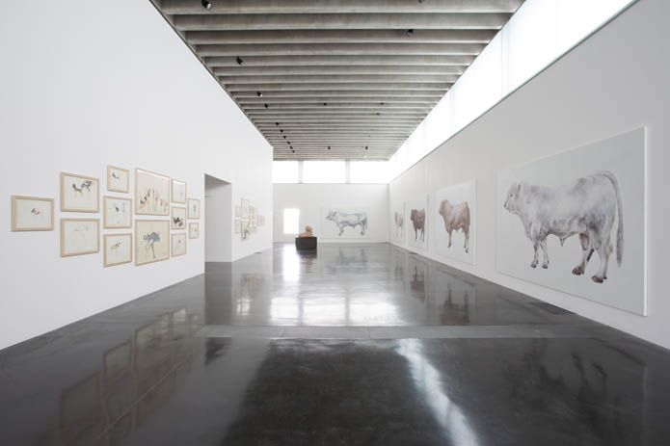
Exhibition View of Main Gallery, New Art Gallery Walsall
The Nature of the Beast
The New Art Gallery Walsall
26th of April – 30th of June
by Giovanni Aloi
The insistent presence of animals in contemporary art is a phenomenon still gathering momentum. But besides the grand, shock-statements of artists like Damien Hirst, a much more complex animal revolution is beginning to surface in the mainstream. This beautifully formed group show in Walsall titled The Nature of the Beast is perhaps its most recent and most successful manifestation, at least in the UK. Staged in the sleek and glossy gallery spaces designed by Caruso St John, this exhibition finally proposes a well curated selection featuring artists whose work has centred on animal subjects from a range of different perspectives. The number of artists on show is limited but their names are all well known: Mat Collishaw, Mark Fairnington, Tessa Farmer, Polly Morgan, Olly & Suzi and Patricia Piccinini. What appears clear from the outset is that this is an exhibition designed to to make us think about our relationships with animals. It is not about marvelling at the beauty of the exotic, the cute and the strange. And this is what these artists successfully achieve through their chosen artistic medium and methodological approach.
The impressive hang of the main gallery proposes a dialogue between Mark Fairnington’s life-size British bulls, Patricia Piccinini’s hybrid sculpture and Olly and Suzy’s drawings of endangered wild dogs of East Africa. The underlying connection between the three can be easily traced to the concepts of wild and domestication. Fairnington’s bulls are presented on white canvasses, seen longitudinally, the animals always face ahead, posing for the viewer in the iconography of the specimen. This approach puts us in a position of visual advantage. The animal body is displayed for the human gaze against the blank dissecting table of scientific epistemology. This positioning of the animal body acquires further levels of complexity in Fairnington’s work as this bull-parade evokes the dynamics of markets. Each bull was painted from an existing individual animal and each still carries an original name such as Turbo Tommy or Soldier— they are simultaneously representatives of their breed and individuals. These are animals engineered by us through a long history of selective breeding. Their names work both as reminder of this history and as markers of the human interventions that has made them what they are. Simultaneously they also speak of exuberant masculinity but also of animal identity: one that we can only understand as being defined by markets, breeders, fashion, and last but not least, the relationship with a farmer. As the artist explains:
"The making of an image of an animal through photography, sculpture and even taxidermy was a way of describing what that animal meant to its owner. A very valuable animal gave importance and social status to its owner and a painting of the animal acknowledged this."
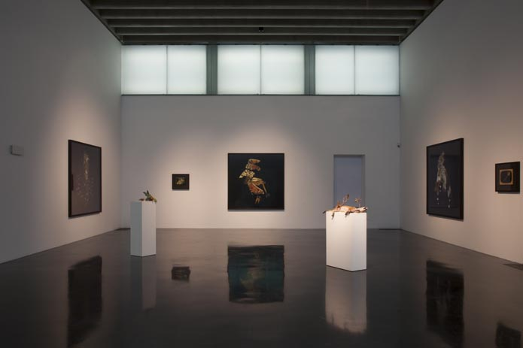
Exhibition view
Facing Fiarnington’s hyperrealist paintings of domesticated animals, Olly and Suzi’s drawings of wild dogs propose the elusiveness of endangered wild animals as precariously pinned down by the simple and rushed tracings on paper. Deliberately disregarding all rules set by the history of “proper wildlife illustration”, these artists paint in the wild, rather than in the studio. Their tracing of the animal encounter is rushed, frenzied and always partial, in assonance with the nature of the experience involved in all wild animal encounters. The result is haphazard, but also urgent and present. The animal encounter lives only in a thin now in which rhetorical symbolism finds no space for orchestration. The aesthetic clash between Fairnington’s static and excruciatingly detailed bulls and the jagged, rushed markings by Olly and Suzy solidely points at the extreme parameters of different epistemic values. The prolonged encounter with the domesticated animal and the fleeting intersection with the wild one are two diametrically opposed, but equally engaging ways of understanding animal lives.
Two enigmatic pieces by hyperrealist artist Patricia Piccinini frame this dialectic opposition. Here, animal-form simultaneously belongs to a distant past and perhaps a not so far away future. Piccinini presents us with a hyperdomesticated gone wild—nature/culture hybrid beings in which, through an implicit process of genetic manipulation, human, animal and machine have merged in uncategorizable ominous beasts. Sphinx, Piccinini’s hyperrealist silicon sculpture is a case in point. Sitting on a plinth in the classical iconography of the Egyptian riddle teller, this human/animal fleshy body opens an orifice to reveal a kidney like organ lying in it. Is it human food for the beast or an offering to the human from the beast?
It is through this positioning of the viewer between the extreme polarities of the wild, the domesticated and the hybrid that the exhibition delves into a fictional, historically charged, sublime animal world through the work of Tessa Farmer, Polly Morgan and Matt Collishaw, all presenting us with Victorian-inspired tableaus in which animal life and death are suspended through the photographic medium or that of taxidermy. Tessa Farmer has for the occasion installed the biggest piece of her career so far. This is the latest instalment of the evil fairies saga. For those whom have not seen Tessa Farmer’s work in the flesh it will be difficult to comprehend how astonishingly believable her incredibly minute skeletal fairies are, especially when juxtaposed to preserved butterflies, flies, ants and bees. In this tableau the fairies have taken control over a hoard of crabs which they use as war machines against an epic battle with a python. The sublime effect caused by the multitude of insects swarming above the scene has to be experienced to be believed.
Matt Collishaw’s contribution to the exhibition is a selection of images from his Insecticide series which presents butterflies and moths horribly crushed and disfigured whilst seemingly suspended in mid air against a black background. The series is printed on 182.9 x 182.9 cm photographic sheets, generating a sensational hyperrealist overwhelming effect. The process of magnification which allows to peer into the microcosms of nature was a pivotal romantic strategy in fashion during the Victorian period aiming at distorting the world in search of spirituality through the immensely vast and infinitely small. Beauty and horror coexist again in these ambiguous pictorial dimensions proposing a tension difficult to emotionally negotiate: how can so much beauty be produced by so much death?
The Victorian animal thread is further explored by Polly Morgan through her distinctive brand of surrealist taxidermy in which nothing is what it seems. Morgan subverts the educational value which taxidermy acquired through the 19th century as main epistemological tool of the natural history museum through interventions which summon fictional, fantastic narratives in which horror and beauty also coexist. In Hide and Fight, an opening on the stomach of a dead stag is revealed to house a seemingly never-ending dark cave filled with resting bats.
The exhibition comes to an end with a final surprise which reassess its critical flare: artist Mark Fairnington has curated a small exhibition titled Our Creatures which is housed in a room within the main exhibition. Based on the genre of animal portraiture, it further explores the complexities of domesticity through themes of human/animal socio/historical interaction. As the artist explains:
These are images and objects that depict in particular the domestic and local relationships between people and animals and show how these could be pragmatic, eccentric, brutal and loving. Here are the creatures that provided friendship, entertainment and sport, they could be made to fight, they could be raced against each other, they could be bred and sold for profit and they could be eaten as food. In these roles they inspired a huge range of human responses; they were and still are a vital part of the human world both emotionally and economically.
The centerpiece of this exhibition within the exhibition is a small taxidermy dog which Fairnington borrowed from the Hornyman Museum in London. The dog is displayed in a glass cabinet, just as it arrived at the gallery in Walsall. It sits inside the cardboard box in which it is normally housed in the Hornyman’s archive, surrounded by the tissue paper which protects it. The simulated livingness of the taxidermied puppy is simultaneously heightened and negated by its setting. One second it is a live puppy jumping out of a box, whilst the second after we become painfully aware that the dog is a museum specimen—its faded museum label partly visible on the upturned lid of the box—the taxidermic spell is broken.
As far as displaying contemporary art involved with questions of animality, this exhibition has set the benchmark by providing viewers with a display in which animals are not simply cute, majestic or horrific but where seriously relevant questions about our relationship with animals are raised.
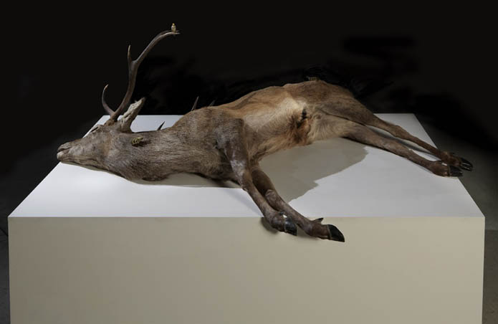
Polly Morgan-Hide and Fight, 2012
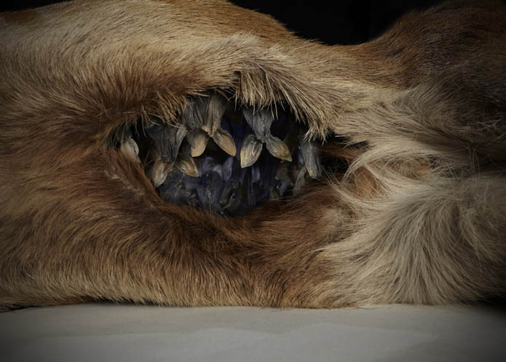
Polly Morgan-Hide and Fight
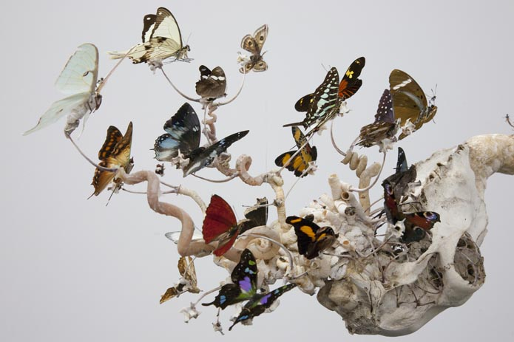
Tessa Farmer-The Perilous Pursuit of a Python
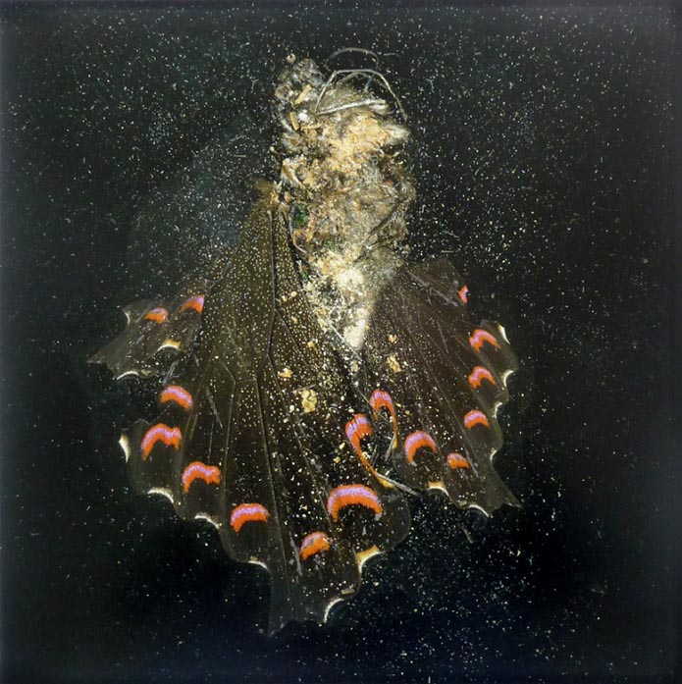
Mat Collishaw-Insecticide #28

___________________________________________________________________

- Culture
- Art and design
- Mat Collishaw

Mat Collishaw: still sensational
It's 25 years since Mat Collishaw burst on to the art scene alongide Damien Hirst and Tracey Emin. And his work is still as appalling and as moving as ever
  - Jonathan Jones
  - The Guardian, Friday 26 April 2013 16.30 BST
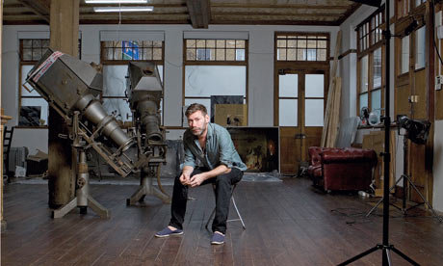
Mat Collishaw in his studio: 'Shock makes us feel more alive.' Photograph: Thomas Butler for the Guardian
A pink lobster rests on a glistening metal platter, surrounded by furrowed brown clam shells and black-eyed, gossamer-legged shrimps. A hunk of bread and a glass of amber liquid complete the still life. Set in a pool of deep shadow, the mutely lit objects in this photograph by Mat Collishaw beautifully resemble foodstuffs painted by some Dutch artist in the age of Vermeer. You might expect to find such a picture hanging in the Rijksmuseum in Amsterdam. But the calm conceals a terrible truth: we are looking at a reconstruction of the last meal of Allen Lee Davis, who was executed in Florida in 1999.
Davis was convicted of a brutal crime: in 1982, he murdered Nancy Weller and her two young daughters, Kristina, nine, and Katherine, five, in Jacksonville, Florida. But his own execution became a grisly farce when the electric chair failed to deliver the clean death it was supposed to, and witnesses heard him scream and saw him bleed. It was the last time the electric chair was used in Florida, which now prefers to end the lives of prisoners with a lethal injection.
For his last meal, Davis requested and got the banquet that Collishaw has reassembled and photographed to look like an Old Master painting: a lobster tail, fried potatoes, fried clams, fried shrimp, garlic bread and root beer.
Collishaw's Last Meal On Death Row series is one of the eerily paradoxical works in which this powerful artist confronts beauty with horror. Other meals in the series are far more restrained. Karla Faye Tucker, who when she died in 1998 was the first woman executed in Texas since 1863, chose a healthy final meal of fruit and salad. Collishaw has pictured it in a sombre light that deliberately recalls paintings by the 17th-century Spanish religious artist and still life master Francisco de Zurbarán. Tucker had converted to Christianity in prison. Collishaw gives his imagined picture of her last meal a spiritual intensity.
In his studio in a converted south London pub, Collishaw is remembering his own religious childhood. His parents are members of the fundamentalist Christadelphian sect, and he grew up in Nottingham in a strictly regulated household where Christmas was not celebrated – he got no presents – and TV was forbidden. "I get on with my parents now," he says, "but those kinds of things were difficult." Once, he recalls, "I came home to find my dad burning all my copies of the Face."
This childhood helps to make sense of his apparent compulsion to break rules, defy moral codes and, as it were, profane the host. Collishaw is an artist of risk and menace, whose work takes its audience to some very dark places. Once there was a name for this kind of provocative imagery: we called it Young British Art.
Collishaw is one of the YBAs, a name coined in the 1990s for a generation or a school or just a gang of artists who were then becoming internationally celebrated. He is a hardcore original YBA whose most famous early work, Bullet Hole, appeared in the exhibition Freeze that his friend Damien Hirst curated in a docklands warehouse in 1988. It is a massively enlarged photograph of a bullet hole in a human head, seen as a purple-lipped orifice surrounded by greasy hair. Through the giant hole you see darkness. Again, there is a religious echo: it is like one of the wounds of Christ in a painting of the Passion. Not that anyone noticed at the time, when Young British Art was tabloid headline, shock-horror stuff and its deeper meanings were rarely considered. Even by people who acknowledged it had any.
Collishaw flitted in and out of the tabloid version of the new British art. He was Tracey Emin's boyfriend, as well as one of Hirst's best pals (as he still is: Collishaw recently took up painting after Hirst gave him 10 huge boxes of paint). And, of all the YBAs, he did project the image of being young, wild and a bit of a romantic. He photographed himself bare-chested in a pond on Clapham Common, trying to catch fairies. He posed as Narcissus gazing in a puddle (not so much recreating a Renaissance painting as restaging the cover photograph from the Smiths' single This Charming Man). A raw, urban romanticism, a whiff of youthful daring came off his art.
And now he is in his 40s.
I owe Mat Collishaw an apology. In 2009 I sat at a boardroom table in Tate Britain discussing who should be shortlisted for the Turner prize, as one of that year's jury. I suggested Collishaw, who was still young enough – Turner Prize artists have to be under 50 – and in my opinion getting better all the time. I thought he deserved to be shortlisted for a series of photographs of butterflies crushed and smashed and seen apparently at the moment of their deaths, enlarged into great gaudy smears of colour. What haunting images of beauty and ruin, life and death. But one fellow juror said this could happen only if we created "an all-YBA shortlist", the last hurrah of the movement that made British art famous. In the thinking of the art world, the Collishaw generation are the establishment now and their stuff is old hat. Sensation and shock are dirty words, crude populism frowned upon now that modern art is the favourite entertainment of the well-heeled middle class. Art now, apparently, is more subtle than it used to be, as are our souls. The mind of visceral art that drew crowds to Sensation! at the Royal Academy in 1997 is judged too brash and loud.
I lost the argument. So no Turner for Collishaw.
Instead, he has a retrospective about to open at the Arter Foundation in Istanbul, a show that foregrounds his political conscience in powerful works such as Last Meal On Death Row. For me, Collishaw is a good political artist for the same reason he is a good religious artist and a good artist-artist. It is because he believes in the efficacy of images. Not for him the abstract evasion, the minimalist half smile – fashionable or not, he wants to punch your imagination in the stomach. He justifies the art of sensation by showing how it can have depth in its oomph.
He is very articulate on the subject, as we chat in his studio while looking through drawers full of Insecticides, the pictures for which I wanted to shortlist him for the Turner. "Shock makes us feel more alive," he insists. Sure, back in the 90s, "Some people were using shock art as a fuck-you-in-your-face kind of thing", but for him shock is much more serious, and all his favourite painters from the past make use of it – "great art that I like when I go to the National Gallery, like Caravaggio and Rubens and Géricault and Delacroix."
The book on his desk is a new academic study of the 19th-century French poet and art critic Charles Baudelaire – specifically, about his drug use. Baudelaire was surely taking drugs when he celebrated his favourite artist, Eugène Delacroix, whose paintings indulge in violent excesses worthy of any artist of today. Delacroix's painting The Death Of Sardanapalus portrays a tyrant killing himself on a vast pink bed surrounded by his harem and slaves in a frenzied apocalyptic party. Its mood of dissipation haunts Collishaw's art. In his photograph Burnt Almonds, he recreates a scene described by a Russian officer in the ruins of Berlin in 1945: a Nazi officer and his mistress lie dead, having taken poison in the middle of a last decadent party. In a new cycle of paintings that Collishaw has created – they are being finished by an assistant in the downstairs of the pub – he enlarges empty cocaine wrappers to suggest the decadence of the high-flying financial world on the eve of the credit crash.
His Nazi picture, he says, shows "a total corruption of beauty". His use of shock always involves "seduction and beauty". I am staring at the Last Meal Of Death Row pictures pinned on his studio wall as he says this. You can scarcely have a starker example of art that lures the eye, only to punish the mind with terrible knowledge. Other subjects he has eerily illuminated with installations and images that are at once beautiful and appalling include war photography, Victorian child prostitution and, most recently, the portrayal of poverty. His Istanbul exhibition includes the premiere of a video in which he stretches photojournalist Kevin Carter's famous image of a child apparently being stalked by a vulture in the Sudan famine in 1993 into an event that happens in time, in slow-motion. By animating Carter's shot, he wants to question the way we take pictures at face value – this image became controversial because some said Carter should have intervened, and he responded by telling contradictory stories about it. Soon after winning a Pulitzer for this perfect press photograph, Carter took his own life. "He couldn't make another image that gave him that buzz," Collishaw says.
In the basement of his pub, we encounter a couple of mangy stuffed animals; Collishaw lives with taxidermist-artist Polly Morgan, and they are currently showing together in an exhibition in Walsall about contemporary art and nature called The Nature Of The Beast. Of all the images with which he seduces and confounds the onlooker, Collishaw's flowers are his most beguiling and disgusting achievements. He has been experimenting with flowers since the 1990s, breeding – he claims – hybrid blooms that attest to genetic mutation. His Infectious Flowers started as photographs and have recently been realised as monstrous sculptures. "I make a beautiful flower," as he puts it, "and then I have to go and infect it with venereal disease." Black sores well up on pink petals, and in his 2012 sculpture The Venal Muse: Fenside, orchidean blooms have turned into gory pustulating columns of suppurating flesh. Nature produces monsters, and life evolves into corrupted versions of itself.
Collishaw placed his venereal flowers instead of bouquets at the entrance to his recent exhibition about the madness of the bankers on the eve of the crash. His art is lovely and vile. It is an art of our time and it hits true, like a bullet in the head.
• Mat Collishaw is at Arter, Istanbul from 2 May to 11 September. The Nature Of The Beast runs until 30 June at New Art Gallery, Walsall
This article was edited on 29 April 2013. The original said that Collishaw was married to Polly Morgan, and referred to the Arter as a centre. Both have been corrected.
Guide, Saturday 27 April 2013, Saturday 4 May 2013, Saturday 11 May 2013

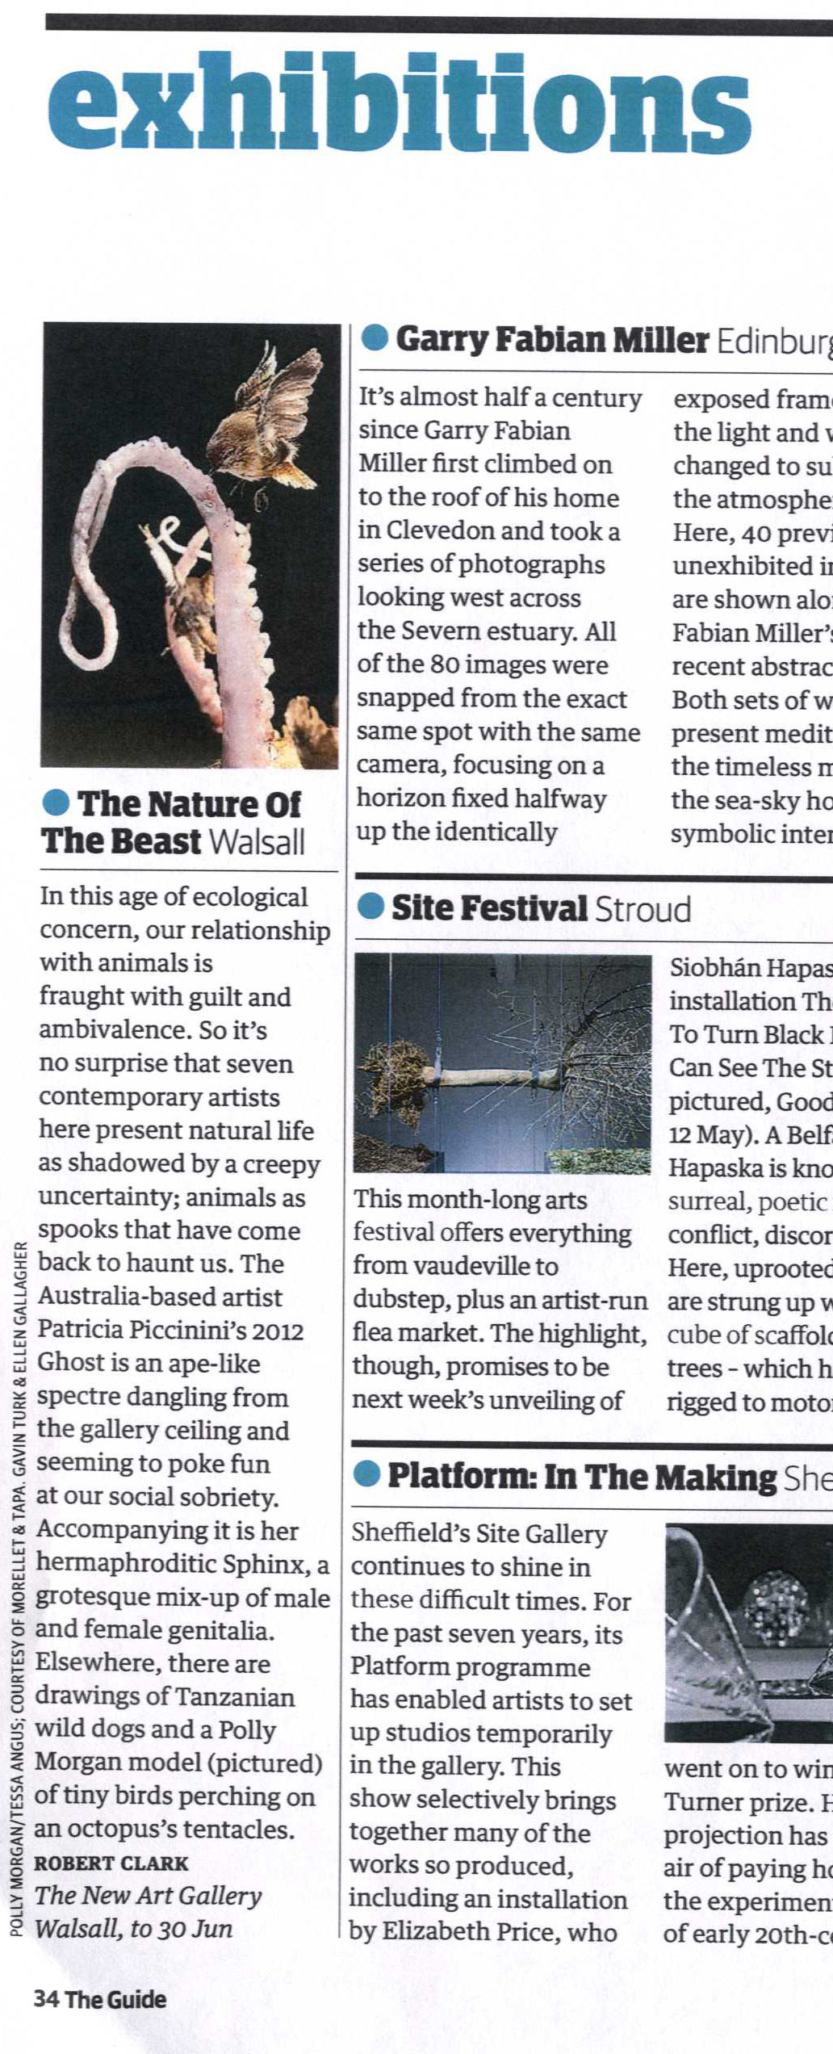
_______________________________________________________

ArtRabbit - listing
international contemporary art

http://www.artrabbit.com

The Nature of the Beast
26. Apr - 30. Jun 13
The New Art Gallery Walsall
Free
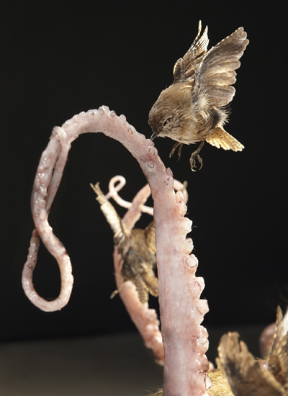
Polly Morgan, Harbour 2012 (detail), taxidermy, rubber and mixed media. Courtesy of the artist. Photo: Tessa Angus
Mat Collishaw, Mark Fairnington, Tessa Farmer, Polly Morgan, Olly & Suzi, Patricia Piccinini
This exhibition will bring together a diverse range of contemporary artists, who through their work, confront and challenge our attitudes towards the natural world, and in particular, the animal kingdom.
Humankind has long been fascinated by animals, who in turn, have been subjected to research, collection, categorisation, documentation, display and experimentation. Each of the artists within the exhibition creates works which involve an intensive scrutiny of animals and nature as well as a critical engagement with the ways in which we have attempted to understand and control the natural world.
Both Tessa Farmer and Polly Morgan will be creating brand new works for the exhibition.
http://www.thenewartgallerywalsall.org.uk/whats-on/exhibition/the-nature-of-the-beast

___________________________________________________________________________

The Nature of The Beast
Website: www.thenewartgallerywalsall.org.uk
Diverse range of contemporary works confronting and challenging our attitudes towards the natural and animal world. Exploring the ways in which we have attempted to understand and control the natural world. Featuring the artists Mat Collishaw, Mark Fairnington, Tessa Farmer, Polly Morgan, Olly & Suzi and Patricia Piccinini.

The Midlands Essential Entertainment Guide
http://www.whatsonlive.co.uk/wolverhampton-and-black-country/Venues/Visual-Arts/
Monday 24 June 2013 – Midlands and Black Country Edition

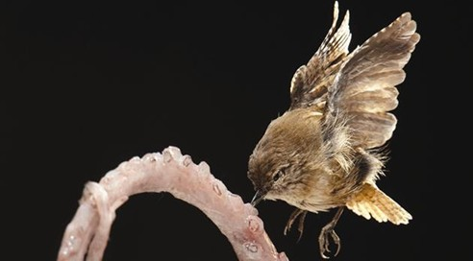
Exhibition which brings together a works from a diverse range of artists, all of whom confront and challenge attitudes to the natural world.

The Nature Of The Beast
Fri 26 April -
Sun 30 June

INTERFACE
Visual art exhibitions and events with a platform for critical writing
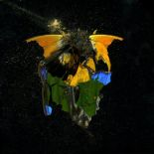[enlarge]

REVIEW

The Nature of the Beast
The New Art Gallery Walsall, Walsall
26 April - 30 June 2013
Reviewed by: Laura Onions »
Upon beginning the cycle of life, every natural being confronts the trials of survival. As humans we seem to forget that we are part of this, setting ourselves above nature’s barbarous world. But still, we are drawn into natures unknown, as we strive to unpick its inner workings through intense scrutiny, experimentation and collection of living creatures. Directed by orchestrated moments of cruelty and beauty, The Nature of the Beast is an exhibition that treads a fine line between allure and repulsion, calling into question the very essence of mankind. What is the nature of the beast?
The artists selected, Mat Collishaw, Polly Morgan, Tessa Farmer, Mark Fairnington, Olly & Suzi and Patricia Piccinni use varying media to critically engage with the ways in which the animal kingdom is documented, categorized and portrayed in both culture and contemporary art. Within this short write up I will highlight the pieces that really struck a chord with me when I visited the exhibition at the New Art Gallery Walsall.
Usually regarded as social and affectionate creatures, the brightly hued taxidermy Lovebirds in Polly Morgan’s Myocardial Infarction scavenge like vultures over a bleeding heart. This violent construction bears a contradiction between beauty and brutality that is unsettling within the viewer, as frozen in time is a reminder of our primal instincts.
Coexisting in the space with Morgan’s three taxidermy pieces are a number of works from Mat Collishaw’s Insecticide series. The pitifully crushed wings of moths and butterflies are amplified in scale allowing the remnants of these minute beings to be studied in detail. The finite becomes infinite as these creatures, symbolic of transformation; death and beauty become celestial bodies at the hands of the artist. Coupled with Morgan’s work the control we hold over creatures smaller or less able than ourselves becomes visible, re-evaluating attitudes towards the animal kingdom.
The immense detail in Mark Fairnington’s six prize bull paintings reflects the reproduction and meticulous breeding of live-stock. Each is stood in an iconic, stoic pose that harks back to the history of painting and is offset by clinical, stark white backgrounds. Stripped from their natural surroundings, the bulls are treated like lab specimens, and come under scrutiny which, as a viewer, you cannot help but par-take in through the awe created by Fairningtons highly detailed and exquisitely painted surfaces.
The ‘beasts’ portrayed within the work of these artists do not represent the natural world but rather a reflection upon ourselves as animal consumers. Our fascinations and fears have culminated in prolonging research and experimentation of animals in order for humankind to maintain control of the world through knowledge and power. Is this survival of the fittest? Is this the true nature of the beast?
Writer detail:
Laura Onions is a fine art graduate, writer and emerging artist.
@Lauraj220
Venue detail:
The New Art Gallery Walsall
Gallery Square Walsall West Midlands WS2 8LG
www.thenewartgallerywalsall.org.uk/whats-on/exhibition/the-nature-of-the-beast

We Heart; Lifestyle & Design Magazine : The UK's most popular online lifestyle and design magazine…

Black Country Culture
a tale of two Midlands towns and their art-led resurrections...

Art & Culture
June 7th, 2013
Forthcoming exhibitions, events and public art. Contemporary artists, graffiti superstars and those who blur the line between product design, fashion and modern art.
The names Anish Kapoor, Damien Hirst, Tracey Emin and Gavin Turk may not be ones you’d expect to find in this large, industrial town, but names you will find they are; thanks to The New Art Gallery Walsall...
A tale of two Black Country towns, separated by the country’s largest (and often most excruciating) motorway, the M6. We’re on our way back north from Littlehampton, the latest leg of our Think Differently road trip – in partnership with Mazda – and The Midlands are our final port of call. The two towns in question are West Bromwich and Walsall, fairly unfashionable parts of central England that live in the shadow of Birmingham, but united by curious cultural interest; for, since the turn of the century, both Black Country towns have been beneficiaries of spangly new arts centres.
Our trusty Mazda6, which we’re going to seriously miss as this road trip comes to a close, has sped us the 180 miles or so from the south coast, with the home of The Baggies our first Midlands destination. Conceived as a ‘Box of Delights’ Will Alsop’s The Public is an architectural behemoth that’s impossible to miss – divisive at the time of its opening in 2008 (after some troubled years in development), the hulking centre for exhibitions, events, community projects and artist residencies has recently celebrated its half millionth visit and its uncompromising design is now largely loved by the locals.
The centre’s colossal exterior, punctuated by bulbous windows and shocking magenta certainly subscribes to our mantra of thinking differently, whilst its interiors are more ‘thinking radically’. A brave icon of inspiring and regenerating a community through art and creativity, The Public is a venue that West Brom’s residents should be proud of.
Talking of ‘thinking radically’, no drive through The Midlands should be complete without traversing the labyrinthine wonder of Britain’s, if not the world’s, most complex motorway interchange; the famous Spaghetti Junction. Officially known as Gravelly Hill Interchange, the serpentine network of Herculean concrete roads and flyovers (that recently celebrated its 40th birthday) has a hidden beauty for fans of urban sprawl and Brutalist architecture – the engineers that masterminded this internationally renowned intersection in the 1960s were certainly thinking differently – and no good road trip would be complete without brushing it to some degree.
And so, further north to Walsall, and our final, final destination on a trip that has opened our eyes to places of cultural interest well outside of the expected. The names Anish Kapoor, Damien Hirst, Tracey Emin and Gavin Turk may not be ones you’d expect to find in this large, industrial town, but names you will find they are; thanks to The New Art Gallery Walsall which, whilst not exactly new any longer (it opened in 2000), is a major draw for those of a cultural persuasion.
Designed by architects Peter St John and Adam Caruso, the gallery now dominates Walsall’s town centre and is definitely the prettiest building around – we arrive just in time to catch current exhibition The Nature of the Beast, Mat Collishaw and Polly Morgan’s emotive works definite highlights. The show’s theme takes us back to Milan Design Week, where the We Heart X Mazda story began, global head of design Ikuo Maeda explaining the brand’s KODO design language, inspired by the “powerful and smooth movements of animals like the cheetah”.
It’s a fitting end to our travels, a reminder of where thinking differently has taken us. It’s time to hand back our Mazda6 and the CX-5 – thank you for joining us on the journey. It’s been emotional…
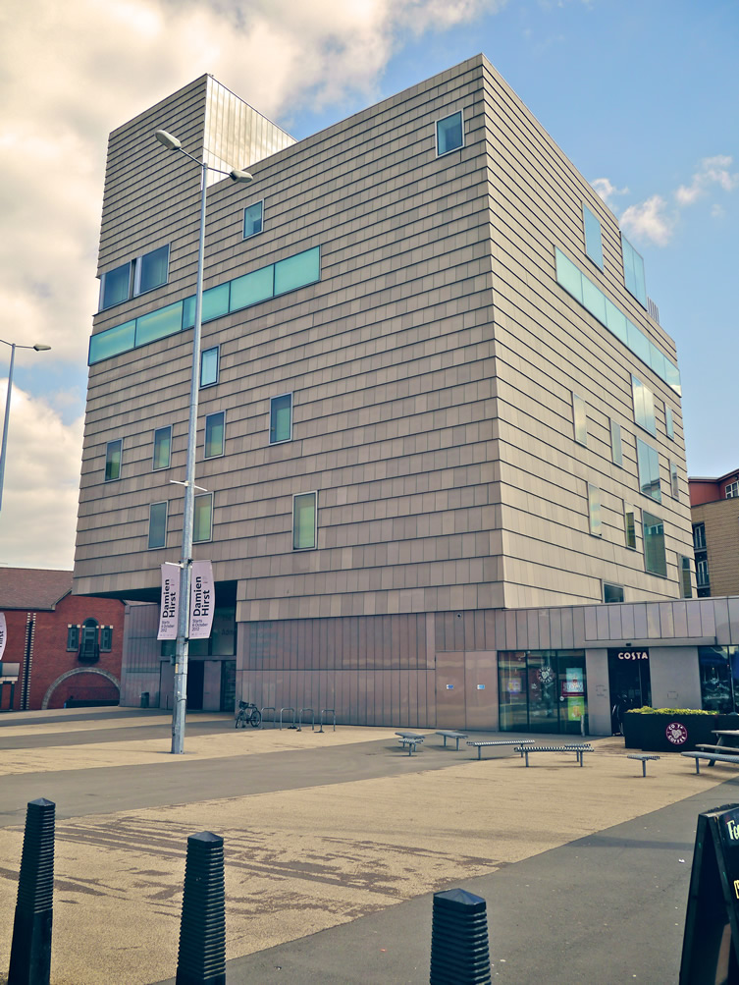

.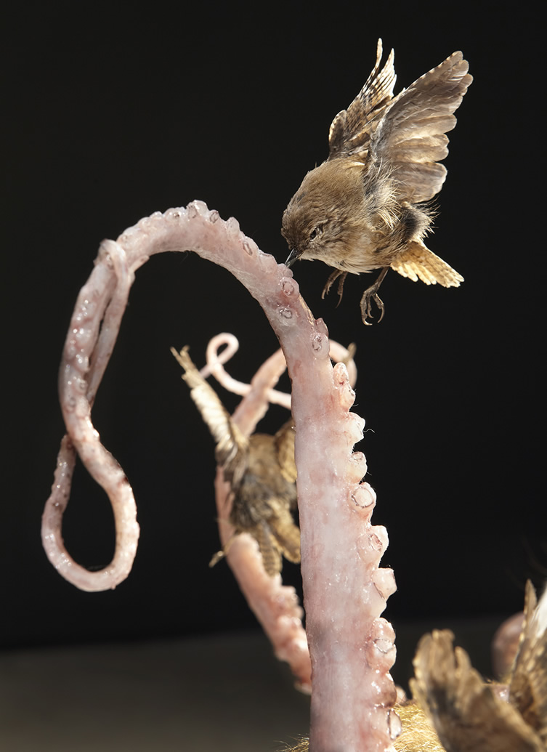
Polly Morgan, Harbour 2012 (detail),
taxidermy, rubber and mixed media.
Courtesy of the artist.
Photo: Tessa Angus

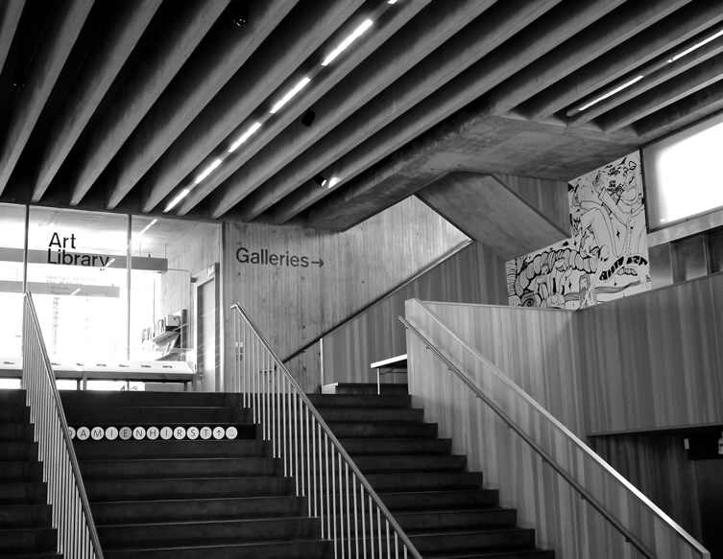
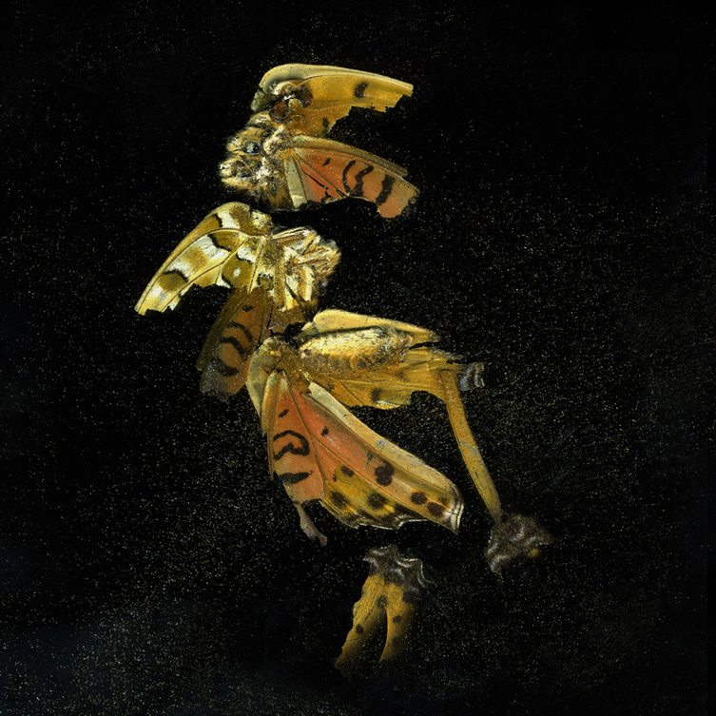
Mat Collishaw, Insecticide 35, 2011,
c-type photo on Dibond.
Courtesy the artist and
Blain Southern, London.
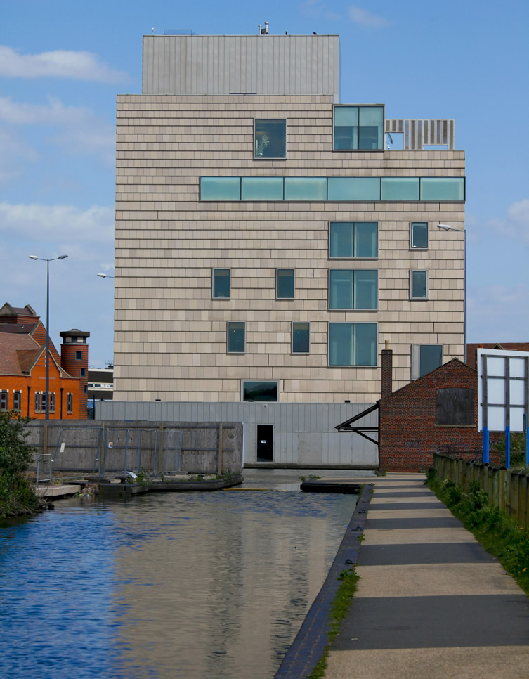
Photo: Craig Holmes,
The New Art Gallery Walsall.

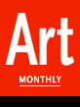

Exhibition Listings - May 2013

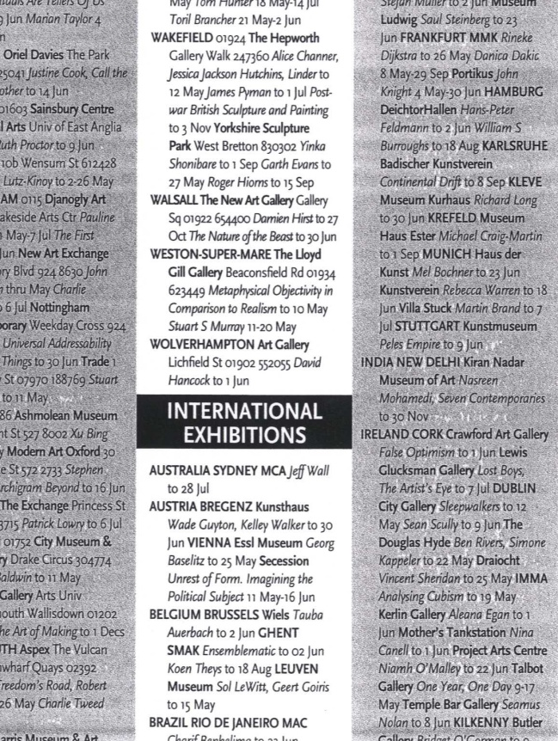

What’s On listings

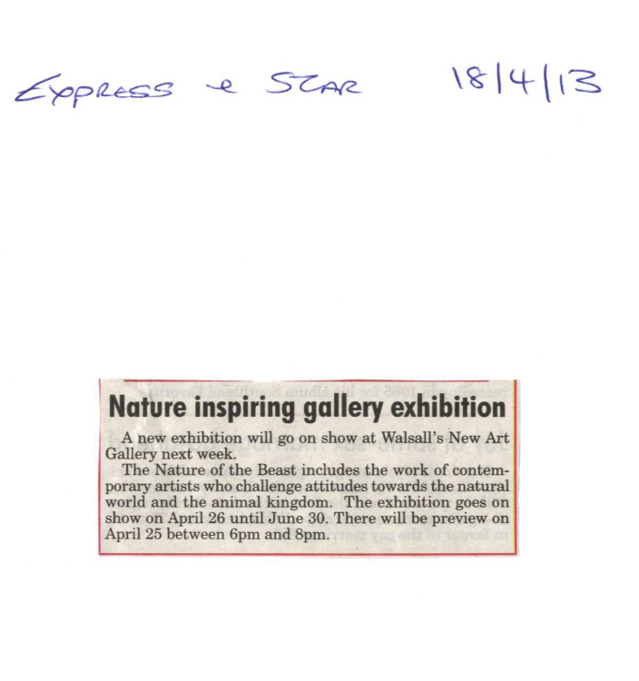

The American – The Transatlantic Magazine
April 2013

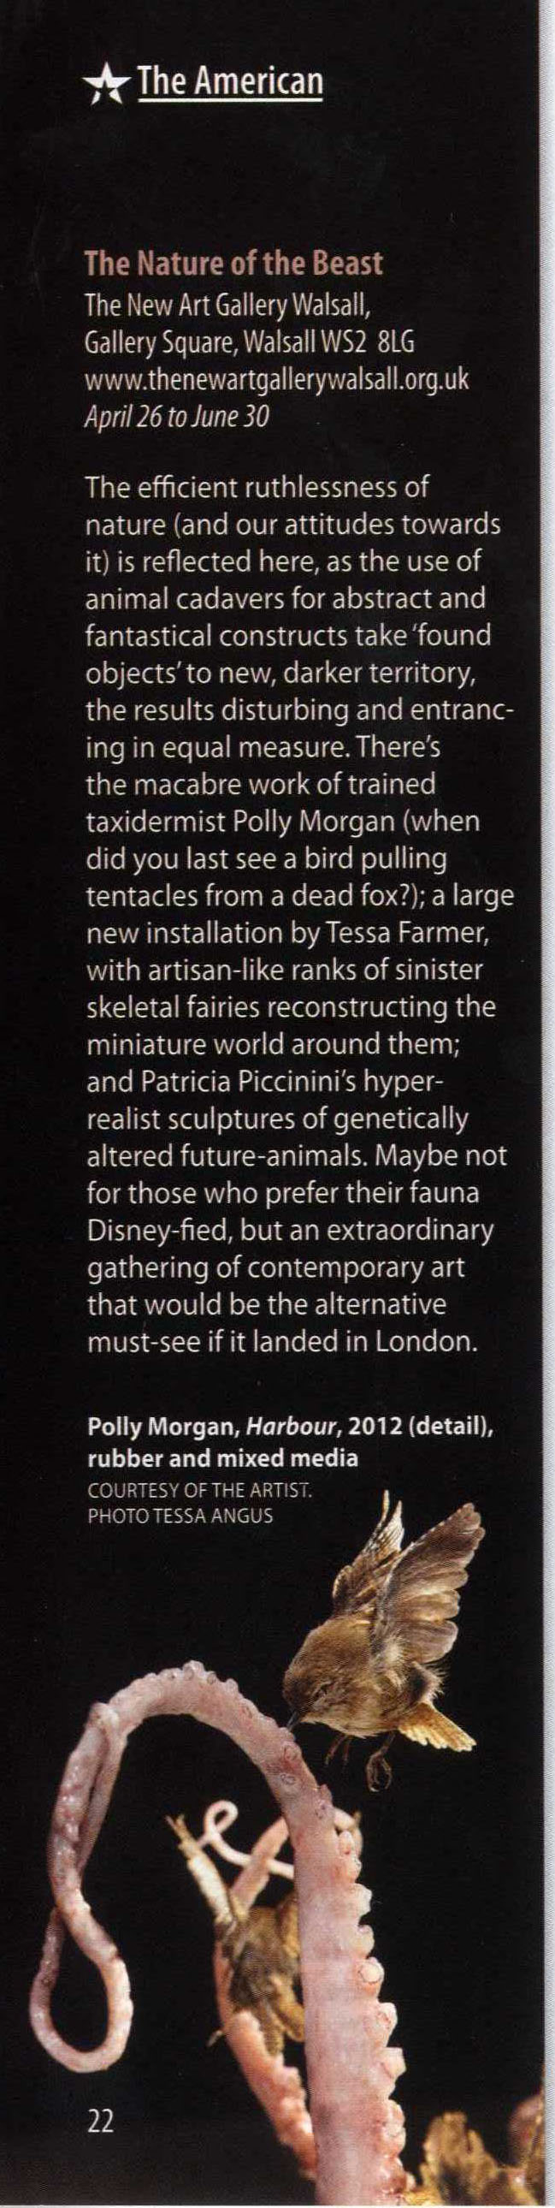

Midlands and Black Country issues – May, June 2013

Visual Arts listings

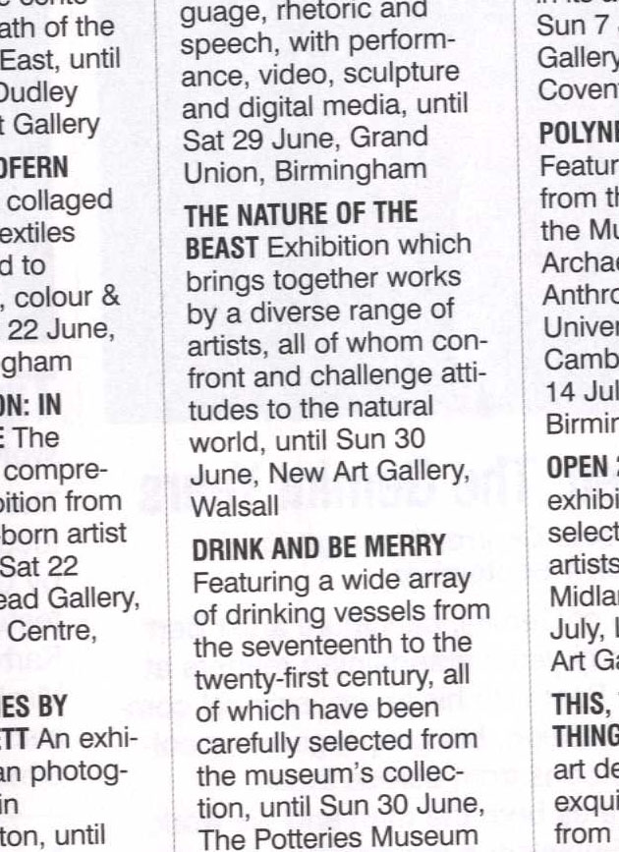

Birmingham Mail
A round-up of the best comedy, music, theatre and exhibitions, May 9-10
Highlights include The Steve Gibbons Band at the Robin2, Bilston, and Yes Prime Minister at the Wolverhampton Grand
The New Art Gallery, Gallery Square, Walsall: The Nature of the Beast, works by contemporary artists challenging our attitudes towards the animal kingdom, until June 30. Damien Hirst – exhibition of works as part of the Artist Rooms on Tour project, until October 27. Jacob Epstein and Damien Hirst: Birth, Death and Religion, until October 27. 01922 654400.

